

Republic of the Philippines
Department of Education
PUBLIC TECHNICAL-VOCATIONAL
HIGH SCHOOLS

Competency-Based Curriculum Material

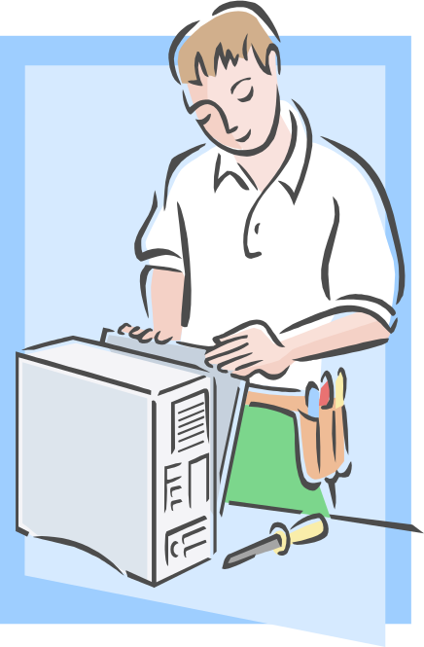

Computer Hardware Servicing

Module #2 | Using Hand Tools
Unit of Competency: | Use hand tools

ACKNOWLEDGEMENT

Copyright Department of Education 2008
First Published JUNE 2008

This module was based on the Competency-Based Curriculum–Contextual Learning Matrix (CBC-CLM) and finalized on the Instructional Modules Finalization Development Workshop conducted at the Development Academy of the Philippines, Tagaytay City, on May 6-10, 2008.

This learning instrument was developed by the following personnel:

Technology Teachers:
- Mr. JemuelJay E. Ybanez
Don Alejandro Roces Sr. Science Technology
- Mr. Joselito H. Zapanta
General Mariano Alvarez Technical High School
- Mrs. Mirasol F. Dasig
San Pedro Relocation Center National High School
- Ms. Evelyn U. Escario
Don Alejandro Roces Sr. Science Technology
- Ms. Cherlyn F. de Luna
Assemblywoman Felicita G. Bernardino Memorial Trade School

Contextual Teacher:
- Mrs. Ma. Josefina Bueno-Luna
E. Rodriquez Vocational High School
Facilitator:
Mr. Abel Elpidez
TESDA CENTRAL OFFICE
Taguig, City
Encoder:
- Mrs. Marites L. Telewik
- Mrs. Milagros P. Aguihap
DepEd
  - Mr. Nelson L. Clerigo

This work was produced with funding provided by the Department of Education.

TABLE OF CONTENTS

Page

How to Use this Module i 1

Introduction ii

Technical Terms iii

Learning Outcome 1 1

Information Sheet 1.1 2

Information Sheet 1.2 4

Information Sheet 1.3 5

Learning Outcome 2 6

Information Sheet 2.1 7

Information Sheet 2.2 8

Self-Check 2.1 10

Activity Sheet 2.1 12

Learning Outcome 3 13

Information Sheet 3.1 14

Information Sheet 3.2 15

Self-Check 3.1 16

Activity Sheet 3.1 17

Learning Outcome 4 18

Information Sheet 4.1 19

Information Sheet 4.2 20

Self-Check 4.1 22

Activity Sheet 4.1 23

Answer Key………..……………………………………………………………………………………..24
Acknowledgement

HOW TO USE THIS MODULE

Welcome to the Module “Using Hand Tools”. This module contains training materials and activities for you to complete.

The unit of competency “Use Hand Tools” contains knowledge, skills and attitudes required for a Computer Hardware Servicing NC I course.

You are required to go through a series of learning activities in order to complete each of the learning outcomes of the module. In each learning outcome there are Information Sheets, and Activity Sheets. Follow these activities on your own and answer the Self-Check at the end of each learning activity.

If you have questions, don’t hesitate to ask your teacher for assistance.

Recognition of Prior Learning (RPL)

You may already have some of the knowledge and skills covered in this module because you have:

- been working for some time
- already have completed training in this area.

If you can demonstrate to your teacher that you are competent in a particular skill or skills, talk to him/her about having them formally recognized so you don’t have to do the same training again. If you have a qualification or Certificate of Competency from previous trainings show it to your trainer. If the skills you acquired are still current and relevant to this module, they may become part of the evidence you can present for RPL. If you are not sure about the currency of your skills, discuss it with your teacher.

After completing this module ask your trainer to assess your competency. Result of your assessment will be recorded in your competency profile. All the learning activities are designed for you to complete at your own pace.

Inside this module you will find the activities for you to complete followed by relevant information sheets for each learning outcome. Each learning outcome may have more than one learning activity.

Date: | LO1. Use Hand Tool | Page
Version | Module2. Using Hand tools | i

Program/ Course: Computer Hardware Servicing NC II
Unit of Competency: Use Hand Tools
Module: Using Hand Tools

INTRODUCTION:

This module contains information and suggested learning activities on Computer Hardware Servicing II. It includes training materials and activities for you to accomplish and complete.

Completion of this module will help you better understand the succeeding module on the use of Hand Tools.

This module consists of 4 learning outcomes. Each learning outcome contains learning activities supported by instruction sheets. Before you perform the instructions, read the information sheets and answer the self-check and activities provided to certain as to yourself and your instructor that you have acquired the knowledge necessary to perform the skill portion f the particular learning outcome.

Upon completion of this module, report to your instructor for assessment to check your achievement of knowledge and skills requirement of this module. If you pass the assessment, you will be given a Certificate of Completion.

SUMMARY OF LEARNING OUTCOMES:

Upon completion of the module the trainees/ students should be able to:

LO1 Plan and Prepare for Tasks to be undertaken
LO2 Prepare Hand tools
LO3 Use Appropriate Hand Tools and Test Equipment
LO4 Maintain Hand Tools

ASSESSMENT CRITERIA:

PRE-REQUISITES:

PC Operation

Date: | LO1. Use Hand Tools | Page
Version | Module2. Using Hand tools | ii

TECHNICAL TERMS

AC power- alternating current
Accidental- adj. happening by chance
Acetylene-
Compartmentalized- adj. a separate section or categories
Computer- machine- capable of accepting information, processing the information and supplying results in desired form.
Contaminants-v. to make impure by contact
Electronics- Pertaining to electron
Electrostatic-
Explosive- tending to explode
Flammable- to burst out quickly
Hazards- n. risk, danger
Malfunction-
Obstructions- something in a way
PPE- Personal Protective Equipment
Technician- an engineering assistant
Tool kit- a small bag or box equipped with hand tools
Trouble shooting- locating and repairing faults in equipment after they have occurred.
Unusual- adj. not in common use, rare; beyond the ordinary
VOM- Volt- Ohms millimeter
Well- equipped- complete with necessary parts/ component

Date: | . LO1. Use Hand Tools | Page
Version | Module 2 Using Hand tools | iii

Program/ Course: Computer Hardware Servicing
Unit of Competency: Use Hand Tools
Module: Using Hand Tools

Learning Outcome #01: Plan and Prepare Tasks to be Undertaken

Assessment Criteria:

- Tasks to be undertaken are properly identified.
- Appropriate hand tools are identified according to the task requirements.
- Selection of tools according to the task requirements

Resources:

Equipment/ Facilities & Materials

- Workshop
- Tables and Chairs
- Computers
- USB Flash Drive
- LCD

References:

- Mc Laughlin, Robert, Sasser, Susan Ralston, Fix your own PC. Philippines Graphics Arts, Inc., Tandang Sora St., Caloocan City
- Legaspi, Carlos, Caina, Mark Anthony Operate A Personal Computer. Dasmarinas Computer Learning Center.
- http://www.workcover.nsw.gov.au/OHS/default.htm
- http://www.MARCOM’S.

INFORMATION SHEET 1.1

Plan and Prepare Tasks to Be Undertaken


Planning, as defined in the dictionary, is an act of formulating a specific system for a definite course of action. It is a very essential part of whatever task there is that needs to be undertaken as it aids one in preparing for the tools/ materials to be used, lets one project the possible scenarios that may arise (such as loose or damage to the tools).

This lesson aims to discuss the proper steps in planning and preparing for the specific tasks to be undertaken.

Planning is a process of preparing for change and development and for deciding how to best manage or influence those changes. Planning is also directed at resolving specific problem issues or conflicts.


A Guide to Plan Preparation
The Policy background to Plan Preparation

Assessment- Students need to be aware of internal and external risk factors and the consequences of any damage/ failure on their hand tools.
Prevention- The student should identify which hand tools is damaged.
Preparation of plans- A plan will be required to be realistic, flexible and meet all the assessed needs of a student at the same time the hand tools itself and the likely needs of recipients of the emergency response.
Education- Anyone involved to any extent in an emergency plan should be aware of his role and be given the opportunity to practice actually doing it.
Testing / Exercising- Any plan must be tested to ensure that it encompasses all the outcomes of known or reasonably foreseeable risks and that it would be effective in providing a sufficient and timely response.
Review- There are a number of circumstances in which a plan may need to be reviewed. Following any test of a plan, or its use in an emergency situation, it is important to analyze whether the planned response was fully effective.
Response- The student should respond to incidents as part of their core activities. Others may only very occasionally be asked to provide an emergency response.

Safety and Risk
An emergency situation does absolve teachers and students from their responsibilities, for their health and safety. All emergency plans should therefore take account of the need to maintain the highest possible standards of safety.

INFORMATION SHEET 1.2

List of Tasks to Be Undertaken
Most efforts to develop identification aids start and end with the recognition key and its computer spin-offs, there are many other identification tasks, starting with the most commonly used: instant recognition. Here is a preliminary list of identification tasks:
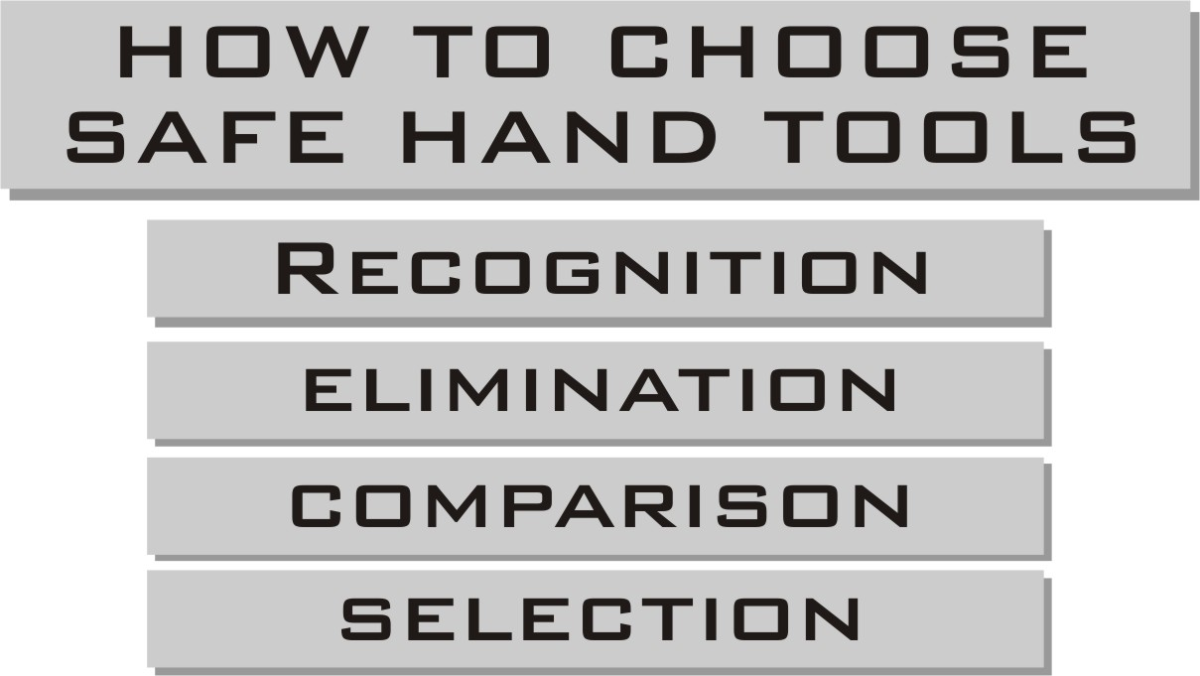

Each is briefly described below, including a definition taken from Webster's Unabridged Dictionary.
Recognition
"The identification of something as being of a certain kind"
Elimination
"To leave out of consideration"
Comparison
"The act of considering the relation between things in order to estimate their similarities or differences"
Selection
"To choose in preference of others"
Selection is the opposite of elimination.

INFORMATIONSHEET 1.3

Time Scheduling Suggestions
Time scheduling will not make you a perfectly efficient person. Very few people can rigorously keep a detailed schedule day after day over a long period of time. In fact, many students who draw up a study schedule and find themselves unable to stick to it become impatient and often give up the scheduling idea completely.
The following method of organizing time has been helpful to many students and does not take much time. It is more flexible than many methods and helps the student to establish long term, intermediate, and short term time goals.

Intermediate Schedule - One per week
CARRY THIS CARD WITH YOU and cross out each item as you accomplish it. Writing down things in this manner not only forces you to plan your time but in effect causes you to make a promise to yourself to do what you have written down
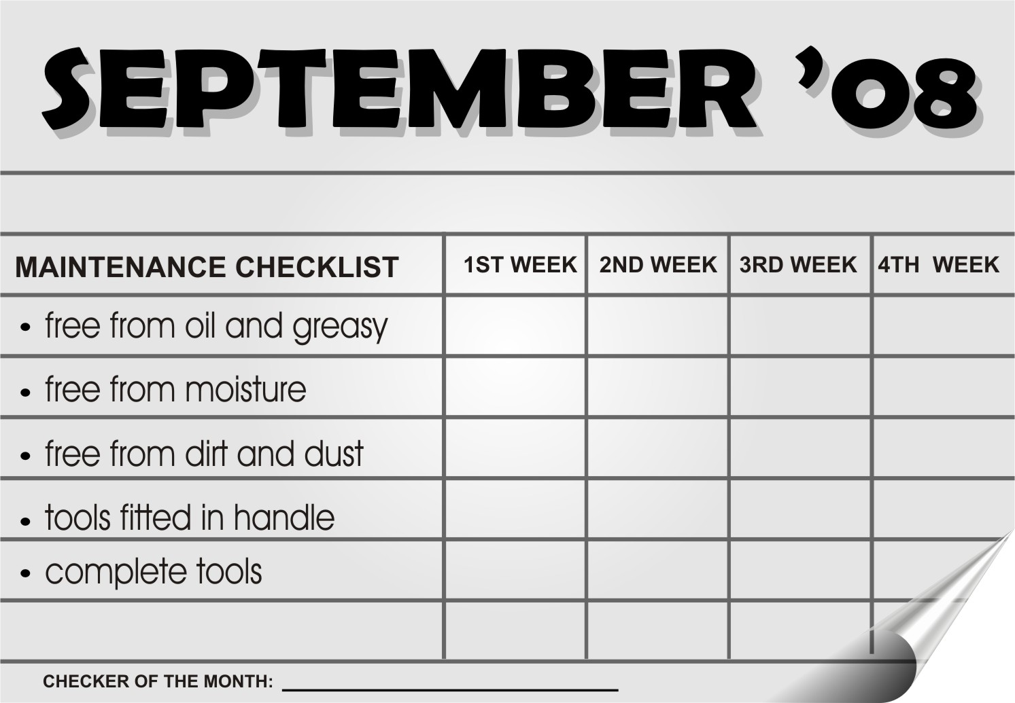
Sample only
Program/ Course: Computer Hardware Servicing
Unit of Competency: Use Hand Tools
Module: Using Hand Tools

Learning Outcome #02: Prepare Hand Tools

Assessment Criteria:

1. Appropriate hand tools are checked for proper operation and safety.
- Unsafe or faulty tools are identified and marked for repair according to standard operating procedure.

Resources:

Equipment/ Facilities Tools & Instruments Supplies & Material

1. Workshop set of Screwdrivers Adapter
2. Tables and Chairs set of Pliers Gloves
Soldering pencil
Desoldering tool
Volt-Ohms Millimeter
Anti-Static wrist wrap
Tweezers
Cutter
Flashlight
Paint brush
Crimping tools
Magnifying glass

References:

- Mc Laughlin, Robert, Sasser, Susan Ralston, Fix your own PC. Philippines Graphics Arts, Inc., Tandang Sora St., Caloocan City
- Legaspi, Carlos, Caina, Mark Anthony Operate A Personal Computer. Dasmarinas Computer Learning Center.
- http://www.workcover.nsw.gov.au/OHS/default.htm
- http://www.MARCOM’S.

INFORMATION SHEET 2.1

Preparing Hand Tools

Before you do any repair work on your PC—in fact, before you even think about taking off the cover of your computer we recommend that you furnish yourself with a computer tool kit. In computer application, the usage of proper hand tools and equipment is very essential. A good troubleshooter must be knowledgeable in the tools and equipment.

HAND TOOLS

Side Cutter Pliers – a tool used for cutting or trimming of connecting wires or terminal leads in the circuit board


Long nose Pliers – Used for holding, bending and stretching the lead of electronics component or connecting wire.
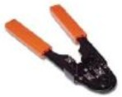

Crimping Tool- a tool made of metal with plastic-rubber handle, to press into small folds, to frill, to corrugate.
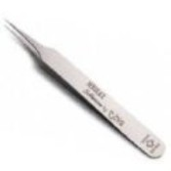

Tweezers- a tool use to hold small sensitive part of a computer.


Cutter- a tool used in cutting wires.

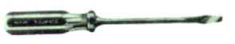
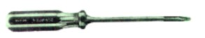
Flat Screw Driver – a tool used to drive or fasten negative slotted screws

Philips Screw Driver- a tool used to drive or fasten positive slotted screws

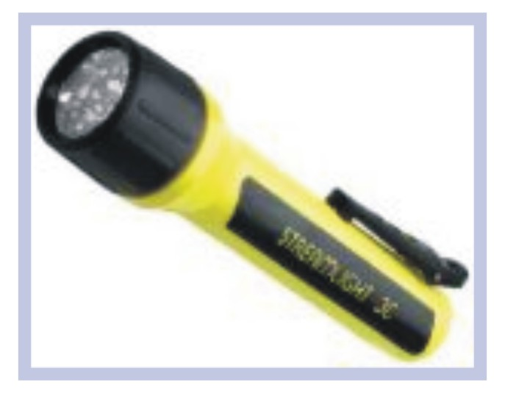

Flashlight- a small electric light, a flash of electric light used to give light in dark conditions.

Paint Brush- a device made of bristles set in handle, use for cleaning sensitive parts of a computer.



Magnifying glass- a device made in glass with handle, to exaggerate or to increase the apparent size of an object.

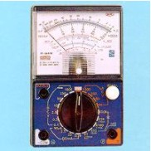

Volt-Ohms-Millimeter (VOM) - A measuring instrument used by technician for measuring: current, voltage, resistance

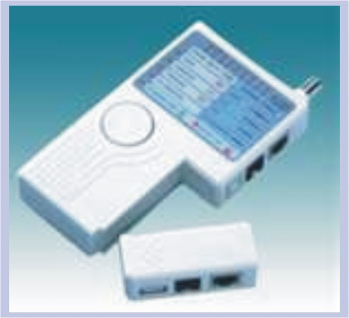

LAN Tester- is a device used to test the network connection.

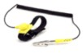

Anti--Static Wrist wrap- is a device used to eliminate electrostatic discharge in your work area.

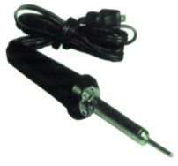

Soldering Pencil – a tool used to join two or more metal conductors with the support of soldering lead melted around it.

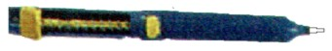
Desoldering Tool – a tool used to unsoldered unwanted parts or component in the circuit with the support of soldering pencil

INFORMATIONSHEET 2.2

Unsafe or Faulty Tools

Hand Tools include a wide variety of non-powered devices such as wrenches, pliers, hammers, and screwdrivers. These tools may seem harmless, but they are the cause of many injuries. The Following are the summary of safety practices related to hand tools.

General hazards:

- The two most common hazards associated with the use of Hand Tools are misuse and improper maintenance.
- Misuse occurs when a hand tool is used for something other than its intended purpose. (An example would be using screwdriver as a chisel. This may cause the tip to break and strike someone).
- Improper maintenance allows hand tools to deteriorate into an unsafe condition. (Example would include cracked wooden handles that allow the tool head to fly off or mushroomed heads that can shatter upon impact.
- Specially designed tools may be needed in hazardous environments. (Always use non-sparking tools in the presence of flammable vapors and dusts. Insulated tools with appropriate ratings must be used for electrical work).

Personal Protective Equipment:

- The type of PPE needed when using tools depends on the nature of the tank. At a minimum, eye protection should always be worn.
- The use of hand protection may also be appropriate to provide protection against cuts, abrasion, and repeated impact.

Do’s and Don’ts in Using Hand Tools

Pliers:

- Do not increase the handle length of pliers to gain more leverage. Use a larger pair of pliers or bolt cutters.
- Do not substitute pliers for a wrench when turning bolts and nuts. Pliers cannot grip these items properly and will slip.
- Never use pliers as a hammer on the handle. Such abuse is likely to result in cracks or breaks.
- Cut hardened wire only with pliers designed for that purpose.
- Always cut a right angle. Never rock from side to side or bend wire back and forth against the cutting edges.

Screwdrivers:

- Never use screwdrivers as a pry bar, chisel, and punch stirrer or scraper.
- Always use screwdriver tip that properly fits the slot of the screw.
- Throw away screwdrivers with broken or worn handles.
- Use magnetic or screw-holding screwdrivers to start fasteners in tight areas.
- Never use pliers on a screwdriver for extra leverage. Only use wrench or screwdrivers specifically designed to accept them.

Utility Knives/ Blades:

- Always use a sharp blade. Dull blades require more force and thus are more likely to slip. Replace the blade when it starts to “tear” instead of cut.
- Never leave a knife unattended with the blade exposed. Consider using a self-retracted knife with a spring-loaded black. (The blade will retract when pressure as the knife is released.
- Keep your free hand away from the line of the cut.
- Don’t bend or apply side loads to blades by using them to open cans or pay loose objects. Blades are brittle and can snap easily.

SELF-CHECK 2.1

Matching Type: Match the Hand Tools in Column A with its function in Column B. Write your answer in sheet of paper.

Column A Column B

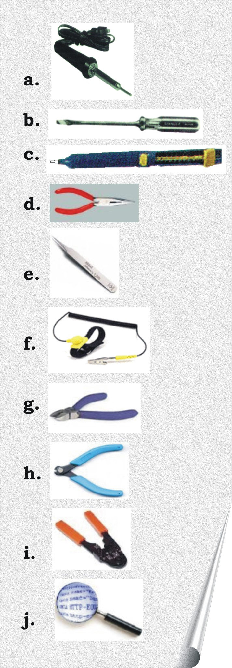
__________1. a tool used to hold small sensitive part of a computer.

__________2. a tool used for holding, bending and stretching the lead of electronics.

__________3. a tool used to unsoldered unwanted parts of component

__________4. a tool used to drive or fasten negative slotted screws.

__________5. a tool used to join two or more metal conductors with the support of soldering lead.

__________6. a device used to exaggerate or to increase the size of an object.

__________7. a tool used to press into small folds, to frill to corrugate.

__________8. a tool used for cutting wires.

__________9. a tool for cutting or trimming of connecting wires.

__________10. it absorbs the static electricity of the material when being hold.

ACTIVITY SHEET 2.1

You will be given ten (10) hand tools. Try to identify and give the function of each.

You will be rated according to the following.

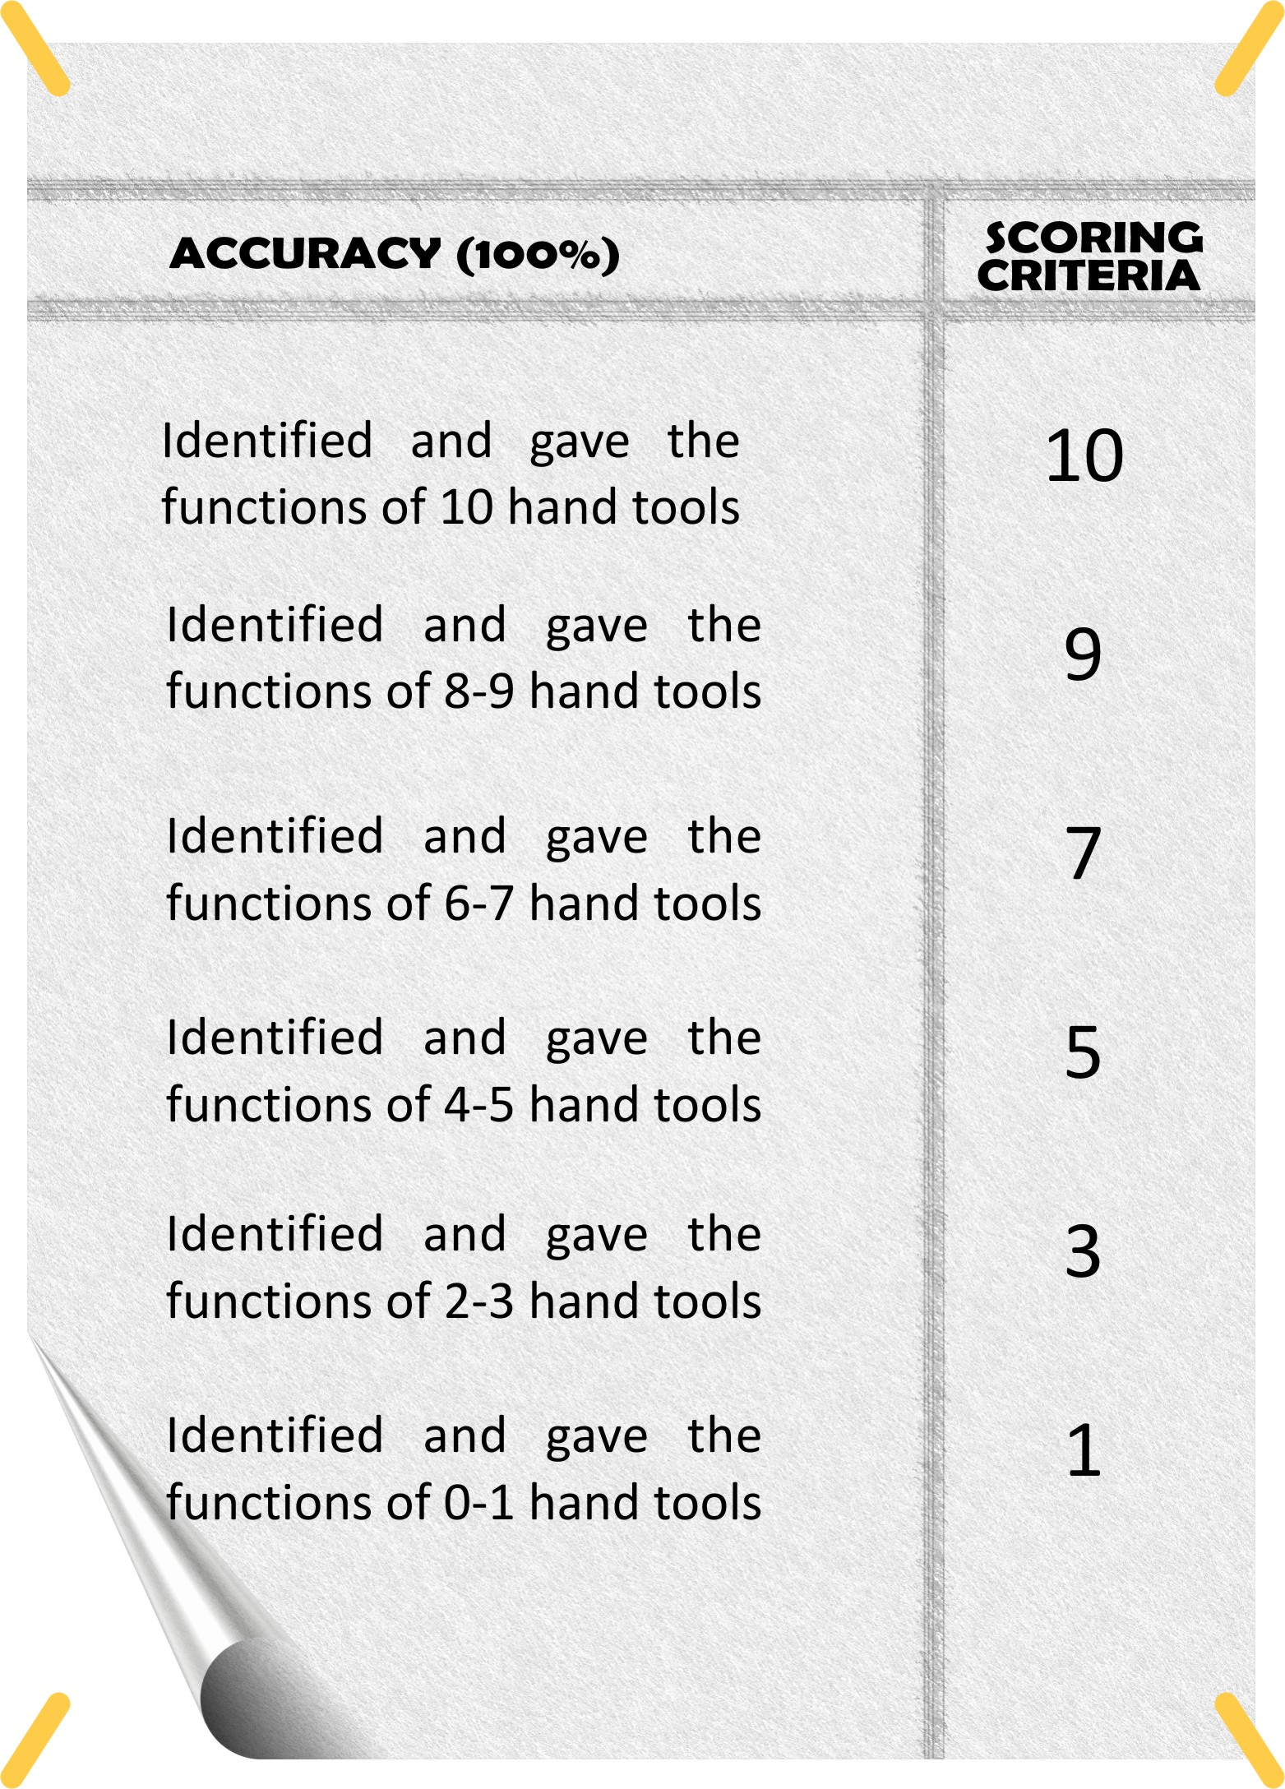

Sample only

Program/ Course: Computer Hardware Servicing
Unit of Competency: Use Hand Tools
Module: Using Hand Tools

Learning Outcome #03: Use Appropriate Hand Tools and Test Equipment

Assessment Criteria:

- Tools are used according to tasks undertaken.
- All safety procedures in using tools are observed at all times and appropriate personal protective equipment (PPE) is used.
- Malfunction, accidental or unusual events are reported to the supervisor.

Resources:

Equipment/ Facilities Tools & Instruments Supplies & Material

- Workshop set of Screwdrivers Adapter
- Tables and Chairs set of Pliers Gloves
Soldering pencil
Desoldering tool
Volt-Ohms Millimeter
Anti-Static wrist wrap
Tweezers
Cutter
Flashlight
Paint brush
Crimping tools
Magnifying glass

References:

- Fix your own PC. Mc Laughlin, Robert Sasser, Susan Ralston, Philippines Graphics Arts, Inc., Tandang Sora St., Caloocan City
- Operate A Personal Computer, Caina, Legaspi, Carlos, Dasmarinas Computer Learning Center.
- http://www.workcover.nsw.gov.au/OHS/default.htm
- http://www.MARCOM’S.com

INFORMATION SHEET 3.1

Personal Protective Clothing and Equipment

Personal safety

Whenever you perform a task in the workshop you must use personal protective clothing and equipment (PPE) that is appropriate for the task and which conforms to your local safety regulations and policies. Among other items, this may include:

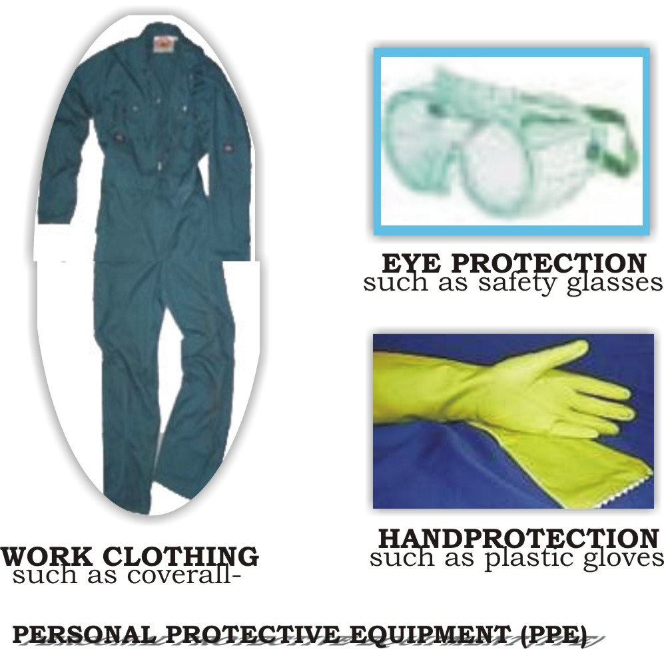

Point to note:

If you’re not certain what are appropriate or required, ask your teacher

Safety check

- Do not use flammable cleaners or water on electrical equipment.
- Make sure designated walkways are kept clear of any obstructions.
- Always wear protective clothing and the appropriate safety equipment.
- Make sure that you understand and observe all legislative and personal safety procedures when carrying out the following tasks.
Point to note:

If you are unsure of what these are, ask your teacher.
INFORMATION SHEET 3.2

Safety Procedure


In many types of work, hand tools are used every day. They make work easier and allow people to be more efficient. However, many students often fail to see the hazards these tools can present. In this module "Hand Tool Safety" shows workers how accidents can be significantly reduced and reviews the various hazards that are associated with specific types of tools.

Safety Requirements

For your protection, observe the following safety requirements:

• Follow all cautions, warnings, and instructions marked on the equipment.
• Ensure that the voltage and frequency rating of the power outlet matches
the electrical rating labels on the system.
•Use properly grounded power outlets

Safety Precautions

To protect both yourself and the equipment, observe the safety precautions

TOOLS | UNSAFE  EXPERIENCE | DO’S & DON’TS IN USING TOOLS
AC power cord  electric | Grounding | Unplug the AC cord from the EC wall socket before working on the power supply.
Wrist strap  electrostatic | Discharge (ESD) | Wear a wrist strap when handling printed.
Printed circuit  boards | Illustrated parts  breakdown | Handle a printed circuit board by the edges
Cover System | Overheating | Replace the cover after performing service on the system

SELF-CHECK 3.1

Directions: Fill in the blanks with the correct answer from the pool below.

- If you experienced the grounding, the __________ should be unplugged.

- Replace the cover after performing service on the __________.

- When the cover system is damaged __________ is likely to happen.

- You are working on a computer with damaged insulation, you will likely to experience __________.

- You should wear a __________ when handling printers circuit boards.



ACTIVITY SHEET 3.1

Demonstrate the use of the following Personal Clothing and Equipment (PPE)

- Work clothing-
a. coverall/apron
b. rubber shoes

- Eye protection-
- Goggles

- Hand protection-
- gloves

Criteria:

Directions: The student will be evaluating thru the given criteria:

The student who got;

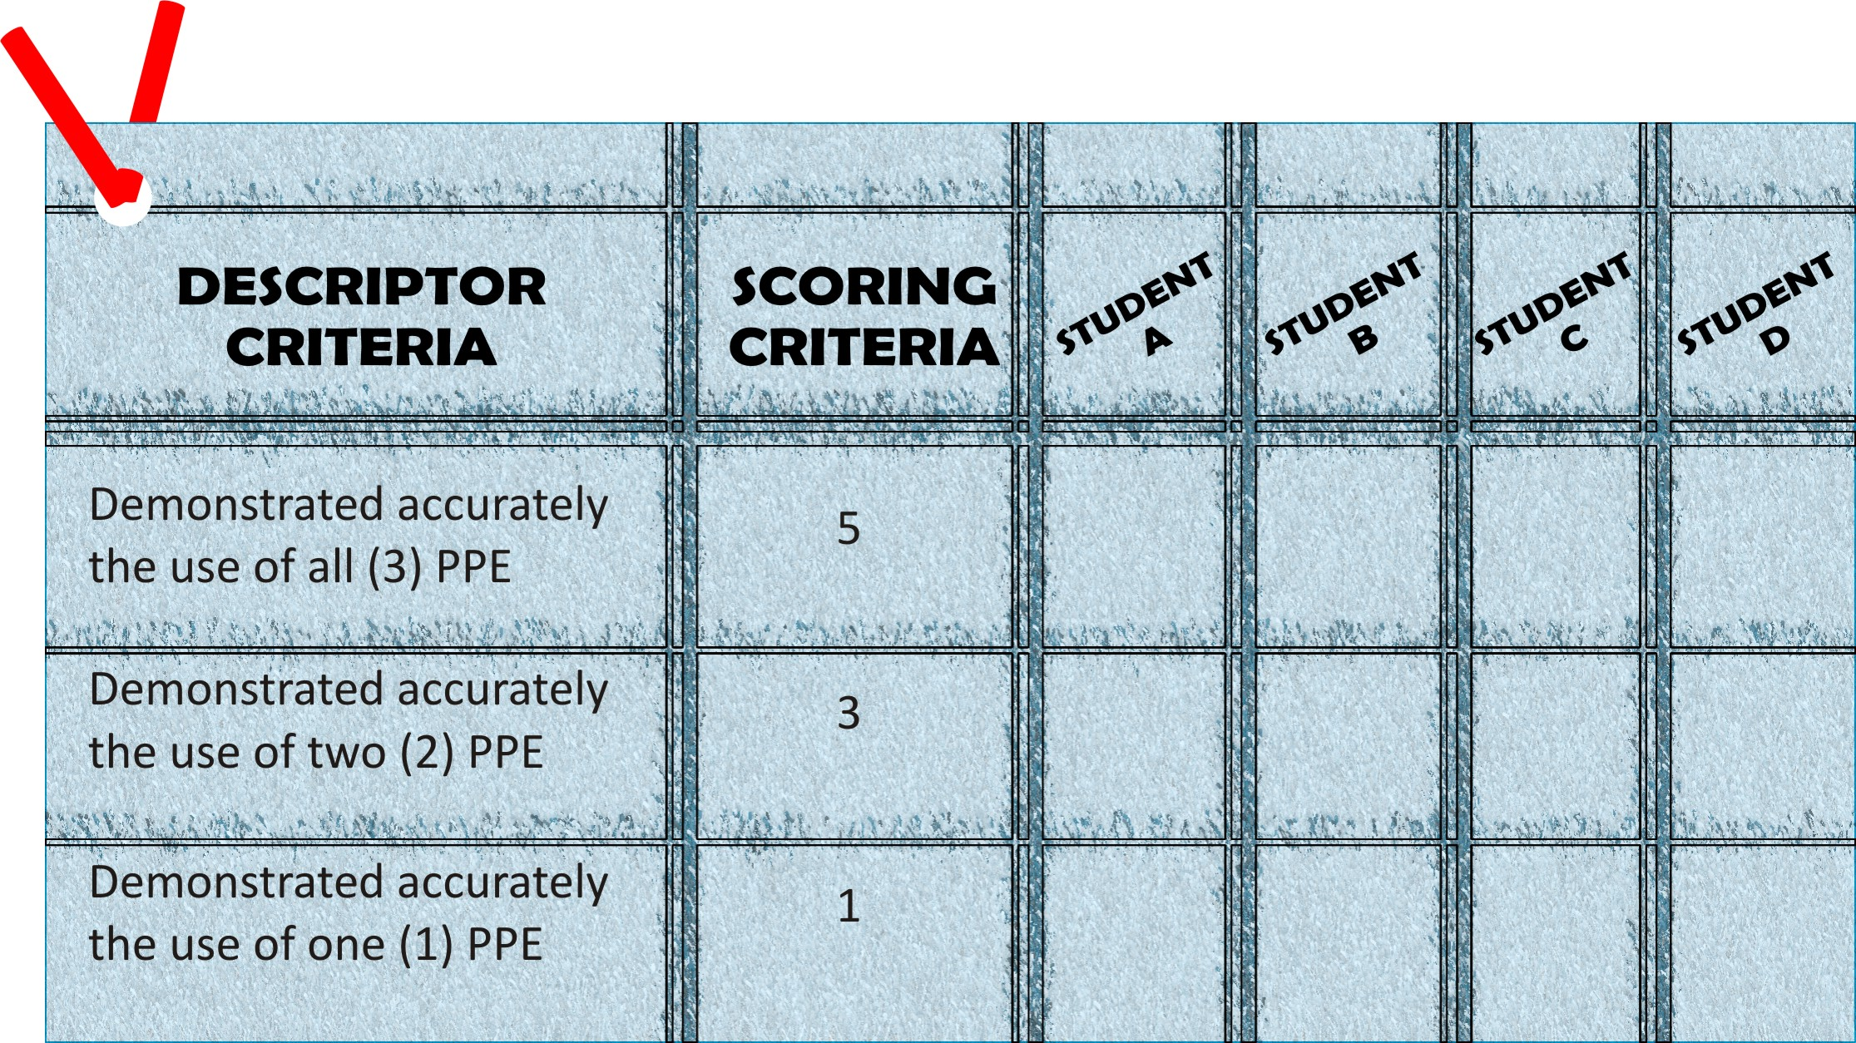

Sample only

Activity Program/ Course: Computer Hardware Servicing
Unit of Competency: Use Hand Tools
Module: Using Hand Tools

Learning Outcome #04: Maintain Hand Tools

Assessment Criteria:

- Tools are not dropped to avoid damage.
- Routine maintenance of tools is undertaken according to standard operational procedures, principles and techniques.
- Tools are stored in appropriate locations in accordance with manufacturer’s specifications or standard operating procedures.

Resources:

Equipment/ Facilities Tools & Instruments Supplies & Material

- Workshop set of Screwdrivers Adapter
- Tables and Chairs set of Pliers Gloves
Soldering pencil
Desoldering tool
Volt-Ohms Millimeter
Anti-Static wrist wrap
Tweezers
Cutter
Flashlight
Paint brush
Crimping tools
Magnifying glass

References:

- Mc Laughlin, Robert, Sasser, Susan Ralston, Fix your own PC. Philippines Graphics Arts, Inc., Tandang Sora St., Caloocan City
- Legaspi, Carlos, Caina, Mark Anthony Operate A Personal Computer. Dasmarinas Computer Learning Center.
- http://www.workcover.nsw.gov.au/OHS/default.htm
- http://www.MARCOM’S.

INFORMATION SHEET 4.1

Maintain Hand Tools

Teacher’s note:

To avoid accidents in the work place resulting from the incorrect use of hand tools, it will be important that you understand the proper use of your items. Have your group discuss your concerns about the dangers involved in using hand tools. During the discussion, each member is reminded of correct methods in manipulating hand tools. During the session, every member practices the correct methods in manipulating hand tools. It is important that everyone has an opportunity to use tools in the practice session. The group leader should prepare in

INFORMATION SHEET 4.2

Proper Use, Maintenance and Storage Tools

The use of safety hand tools should be a key component of most industrial safety programs. An understanding of the hand tool’s intended use and environment, combined with proper tool selection, maintenance and storage, will greatly reduce the risk of harmful accidents.

The following common-sense guidelines for Tool Use, Maintenance and Storage:

- Keep hand tools clean and free from ferrous or other contaminants.
- Do not use hand tools in direct contact with acetylene, due to the possible formation of explosive acetyl ides, especially in the presence of moisture.
- During normal use, all pliers and screwdrivers will progressively develop some damage to the striking faces of screwdrivers or the cutting edge and striking end of pliers. As part of the normal operating and safety procedures, these tools should be returned to the workshop, as with steel tools, to have the faces and heads redressed. This is essential to prevent eye damage resulting from chips detaching from the item during use.
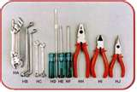
- Do not hand tools fitted with wooden handles in places where the handles may dry out and shrink. This will increase the risk of the handle breaking or the head becoming loose.
- Tools are designed for specific use. As with any tool. In addition to the probability that the tool will be damaged, this is a dangerous practice for the safety of the operator.
- The accepted standards of safety and maintenance for common steel hand tools must also be adopted with non-sparking hand tools, in addition to any specific recommendations resulting from the alloys used.
- When sharpening hand tools, follow normal safety procedures, such as the provision of eye and face protection, adequate extraction and dust collecting facilities.

Point to note:


Clean tools and equipment work more efficiently. At the end of each working day clean the tools and equipment you used and check them for any damage. If you note and damage, tag the tool as faulty and organize a repair or replacement.


Electrical current can travel over oily or greasy surfaces. Keep electrical power hand tools free from dust and dirt and make sure they are free of oil and grease.


All workshop hand tools and equipment should have maintenance schedule. Always complete the tasks described on the schedule at the required time. This will help to keep the hand tools in safe working order.


Store commonly used hand tools in an easy-to-reach location. If a tool or a piece is too difficult to return, it could be left on a workbench or on the floor where it will become a safety hazard. Keep your work area tidy. This will help you work more efficiently and safely.

SELF-CHECK 4.1

Direction: Use your answer in a sheet of paper.

1. Keep hand tools clean and free from _____ and _____.
- dirt and dust c. water and soda
- ferrous and other contaminants d. none of the above

2. Do not use hand tools in direct contact with _________, due to the possible formation of explosive acetyl ides, especially the presence of moisture.
- acetone c. alcohol
b. acetylene d. none of the above

3. If you used a damage hand tool, what will you do?
- tag a tool c. put in a trash can
- don’t use it d. none of the above

- As part of the normal operating and safety procedure, these tools should be returned to the __________.
- bedroom c. workshop
- office d. none of the above

- When sharpening hand tools, follow normal _____ procedure.
- friendly c. safety
- common d. unsafe

ACTIVITY SHEET 4.1

Direction: Answer the following briefly.

- What appropriate action should be done if the hand tool is damaged?

- If the screwdriver is oily or greasy, what is the proper thing to do?

- You are working in an untidy work station, what will you do?

ANSWER KEY (USING HAND TOOLS)

Self-Check 2.1

1. e 6. j
2. d 7. i
3. c 8. h
4. b 9. g
5. a 10. F

Self-Check 3.1

- AC Power cord
- Cover System
- Overheating
- Electric shock
- Wrist strap

Self-Check 4.1

- B
- B
- A
- C
- C

